# Design

## Assumptions

Those constraints that are risks which have to be taken in order for a design process to begin.

## Text

A list of IDs and their associated text messages used for internationalizing words on a screen, menu, or other small pieces of text. This is technically called externalized text.

### Messages

* M#1 –

### Errors

* ERR#1

## Screens

A separate file to collect design recommendations from users and analysts for either suggestions on final design or for ideas while thinking through the requirements.

**SD#1** – Selection panel

**Type** – User elicited - analysis

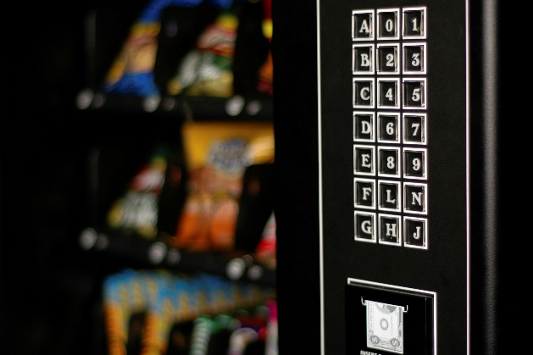

## Reports

A separate file to collect design recommendations from users and analysts for either suggestions on final design or for ideas while thinking through the requirements.

R#1 – Report layout

|  |  |  |  |  |  |  |  |
| --- | --- | --- | --- | --- | --- | --- | --- |
| Header info | | | | | | | |
| Sort 1  Header with page break | Sort 2  Header | Sort 3  Ascending | Sort 4 |  |  |  |  |
| Field 1 | Field 2 | Field 3 | Field 4 | Field 5 | Field 6 | Field 7 | Field 8 |
| Formatting to apply - | Links to  detail - screen |  |  |  |  |  |  |
| Total on  Sort 1 |  | Total on  Sort2, Sort 3 |  |  |  | Total on All | Total on All Average All |
| Footer info | | | | | | | |